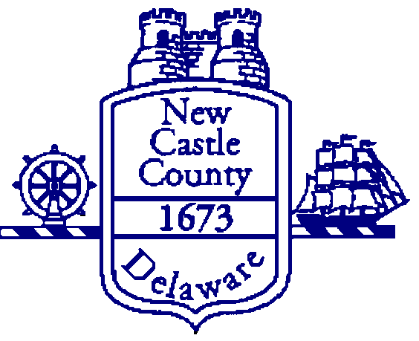

DEPARTMENT OF COMMUNITY SERVICES
CERTIFICATION OF ZERO INCOME
To be completed by all adult household member claiming zero income.

Name:____________________________________________________________ NCC Program Name:________________________
Address: ____________________________________________________________________________________________________
I hereby certify that I do not individually receive Income from any of the following sources:
    - Wages from employment (including commissions, tips, bonuses, fees, etc.);
    - Income from operation of a business;
    - Rental Income from real or personal property;
    - Interest or dividends from assets;
    - Social Security payments, annuities, insurance policies, retirement funds, pensions, or death benefits;
    - Unemployment or disability payments;
    - Public assistance payments;
    - Periodic allowances such as alimony, child support, or gifts received from persons not living in my household;
    - Sales from self-employed resources (Avon, Mary Kay Uber, etc.);
    - Any other source not named above.

NOTARY
The signature of the Applicable Party (Applicant or any Adult Household Member with zero income) must be notarized to verify the identity of the individual who signed this document using the appropriate notary certificate of the state, territory or insular area.

Date:________________________________________
Signature:____________________________________

Under penalty of perjury, I certify that the information presented in this certification is true to the best of my knowledge. I further understand that providing false information on this page constitutes an act of fraud. False, misleading or incomplete information may result in termination of assistance.
_________________________________ _________________________________ _____________
Signature of Applicable Party Printed Name of Applicable Party Date

